**RUN TIME CONTROLLER**

Recording scripts

* Open JMeter.
* Right click on Test Plan.
* Click on Thread(Users) -> Thread Group.

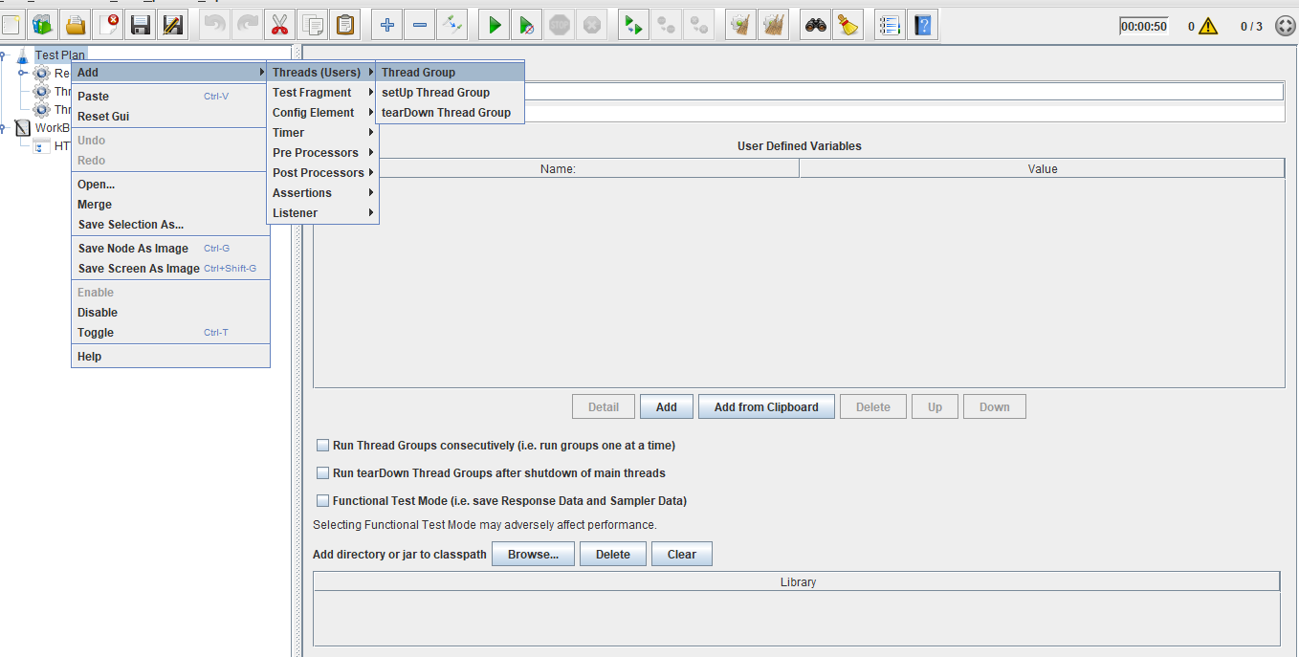

* Right click on Work Bench.
* Click on Add -> Non Test Elements ->HTTP(s) Test Script Recorder.

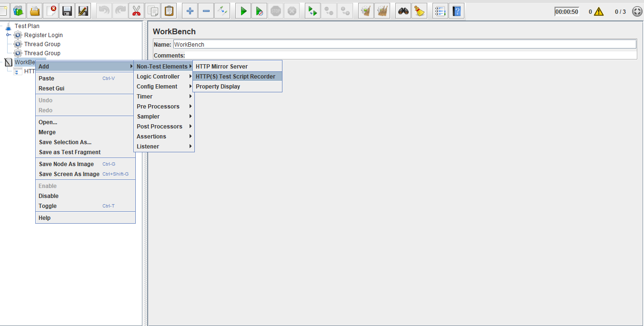

* Right click on Thread Group.
* Click on Add -> Logic Controller->Recording Controller.

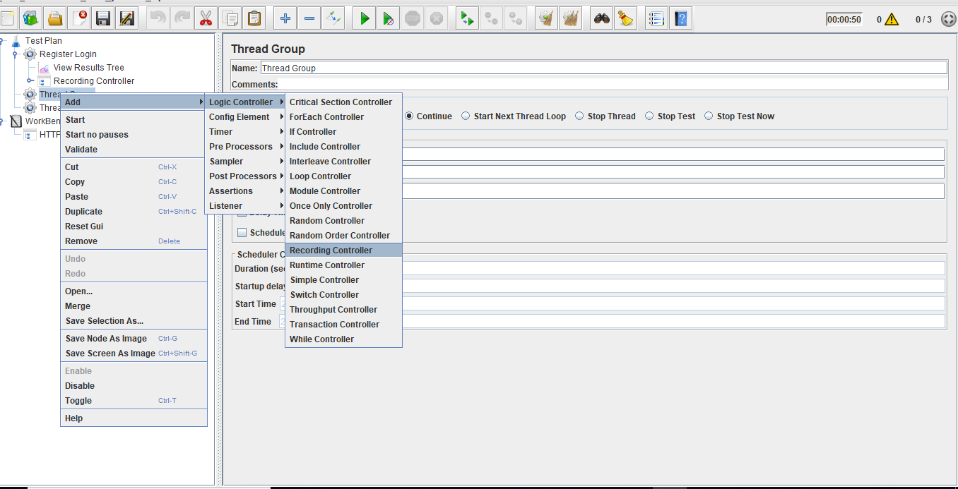

* Right click on Thread Group.
* Click on Add -> Listener->View Result in Tree.

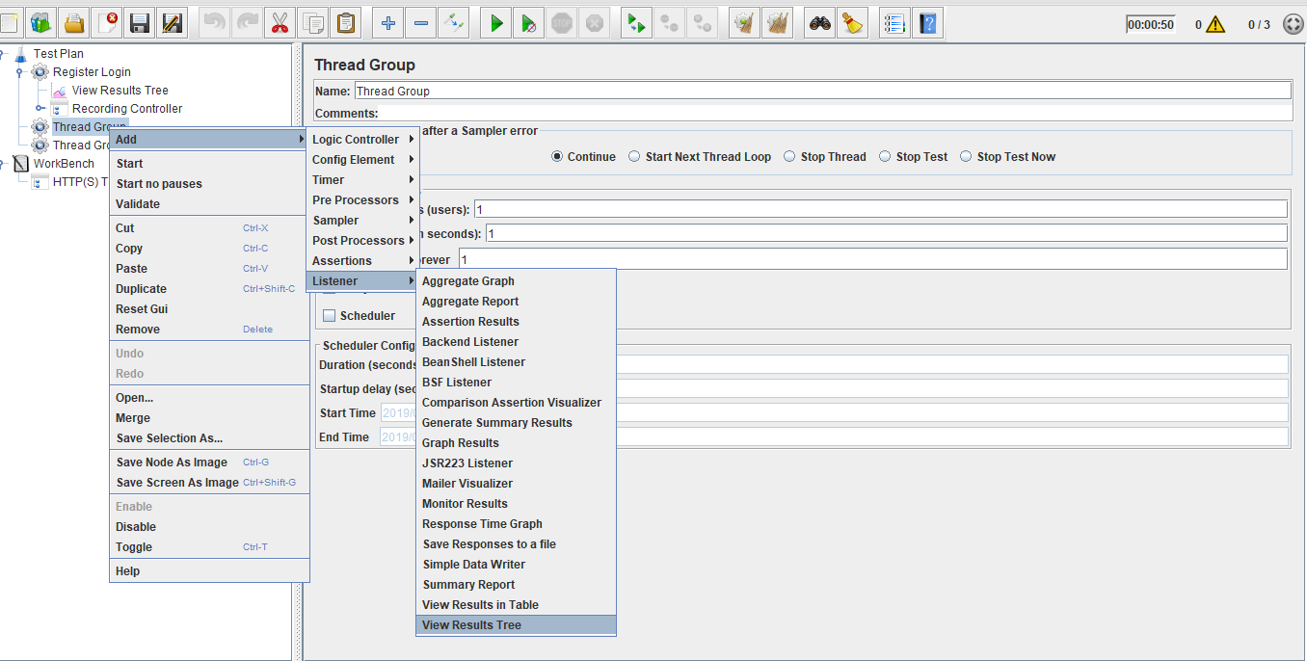

* Configure proxy settings in the browser.
* Run the scripts.
* Automatically JMeter records the scripts.

**Step 1.15.2:** Adding runtime controller

* Right click on Thread Group.
* Click on Add -> Logic Controller -> Runtime Controller.

### 

**Step 1.15.3:**  Running the scripts in runtime controller

* Recording scripts should be added as child scripts for the runtime controller.
* Provide the runtime and run the scripts.

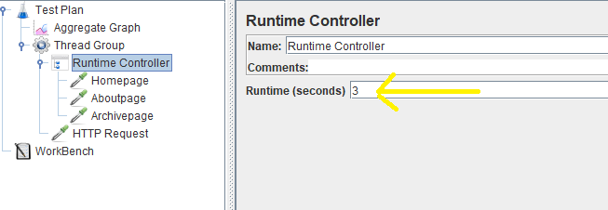

* Run the throughput controller and view the results as below:

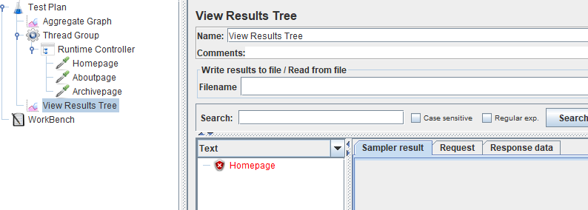

* **Note:** Number of running scripts will depend on runtime.